**How to dual boot WINDOWS 10 and Ubuntu**

**Answer :** Both windows and Ubuntu are operating systems. To boot them on same device we can follow the below steps ,

**Prerequisite**

* Laptop with OEM installed Windows 10
* One USB stick min 16GB for Windows 10 recovery
* One USB stick with latest bootable Ubuntu. To create Ubuntu bootable stick, use Rufus.

**Backup and Recovery**

Before you begin, make sure you take backup of your personal data to an USB stick. Also for Windows 10 system files, create a recovery stick. Follow below instruction to create a recovery USB.

* Insert an empty 16GB+ USB stick to Windows 10 machine
* Open Control Panel
* Search with ‘recovery’
* Click on Create a recovery drive
* Wait till the recovery is complete. Once completed, safely remove the USB stick from machine

To be on the safe side, you can check whether the recovery stick works via booting from it.

**Create Partition for Ubuntu**

OEM installed machines with Windows 10, typically comes with two basic partitions (excluding the recovery partitions). C:\ and D:\. C Drive contains Windows 10 system files and D Drive is reserved for user data. Ubuntu (18.04) needs minimum 25GB of storage space partition which we need to create by shrinking C:\ drive which typically contains majority of the space. Follow below steps to create a partition for Linux.

* Open partition editor from START menu by searching ‘partition’.
* Right click on C Drive and click ‘Shrink Volume’.

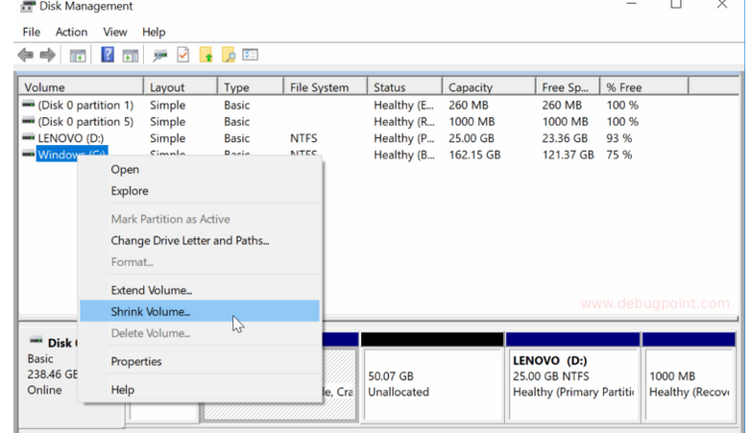

* In next window, you can see the available size available in MB. Enter the value as per your need in MB in the ‘amount of space to shrink in MB’.

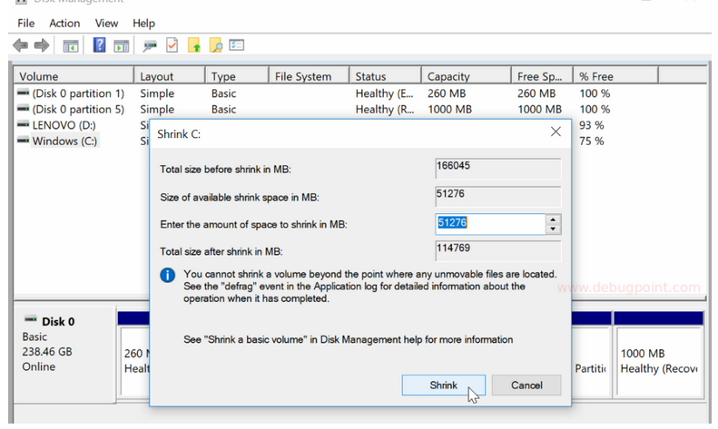

* Click ‘Shrink’ and wait it finishes.
* You will see an unallocated space is created in graphical display of your storage. This space would be used to install Ubuntu. Do not format now as Ubuntu installer would give you option to format during installation.

## Configure BIOS to change SATA to AHCI

If your system’s SATA controller mode is set to AHCI, you can skip this step. You can check it via entering into BIOS via function keys while booting up.

Ubuntu installer can not detect disk partitions if SATA controller mode as SATA RAID IDE, or Intel RST. If you try to install Ubuntu in above created partition with SATA controller mode as SATA RAID IDE or Intel RST, you would encounter below error: ‘You need at least 8.5 GB disk space to install Ubuntu.”.

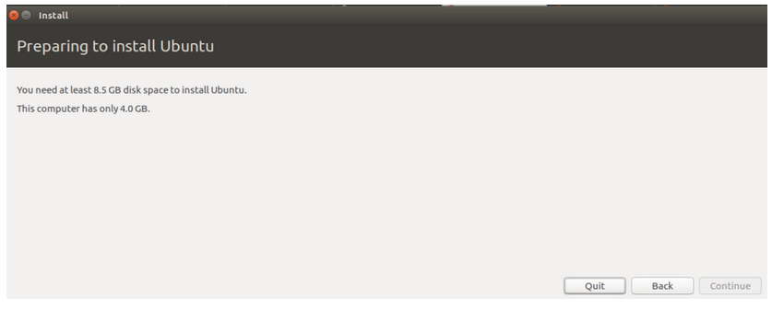

To change SATA controller mode to AHCI, follow below steps.

* Open ‘cmd’ from start menu as Administrator.
* Run below command to turn on the safe mode in next reboot.

**Install Ubuntu**

* If everything works well till now, Ubuntu installer would start from USB stick.
* Continue to follow the on-screen instruction till Installation Type windows.
* In the Installation Type window, choose ‘Something Else’.

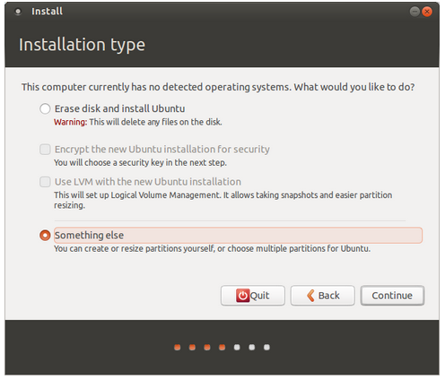

* In the partition list, select the partition which you have created in the first step. Then click Change. In the next window, select mount point as “/” and Type=ext4. Press ok.
* Select the root device in the boot loader installer drop-down. DO NOT choose Windows Bootloader.

[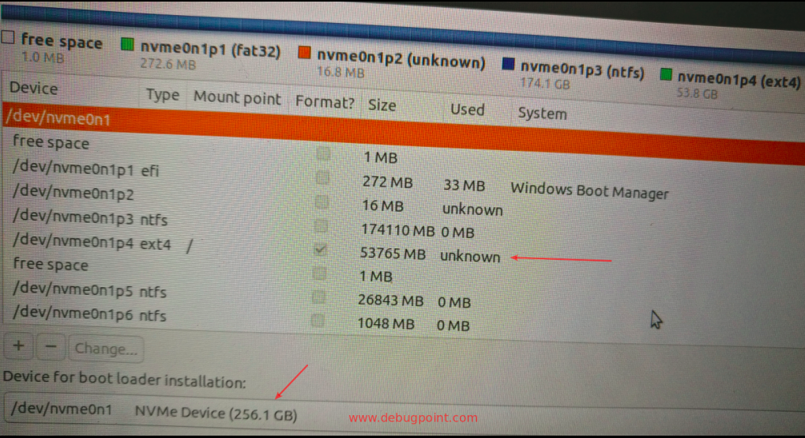](https://www.debugpoint.com/blog/wp-content/uploads/2019/01/Select-Drive-to-Install.png)

* Press ok. And continue the installation and follow instruction on screen.
* After installation is complete, the installer would reboot the system. Remove the Ubuntu bootable USB stick before reboot.

That’s how we can boot Ubuntu alongside windows 10.